ALGORTIHMS AND DATA STRUCTURES
NAME : L.VATSHITHA
REG:23BCE8936
1)Linear Search
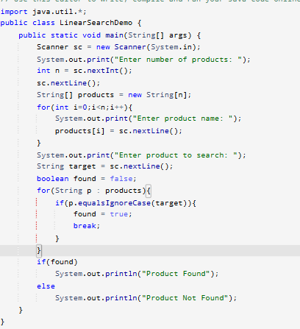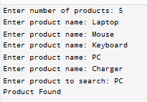
Binary Search
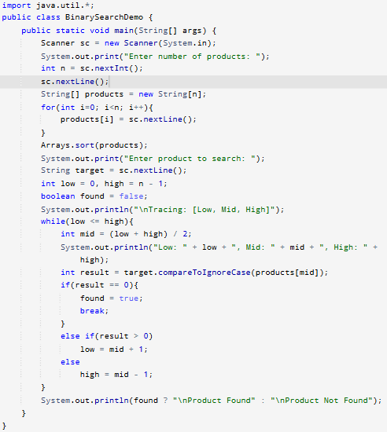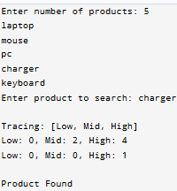
Search | Complexity
Linear Search | O(n)
Binary Search | O(log n)
1. Linear Search
- Best Case: The element is found at the first position.
Time Complexity: O(1)
- Average Case: The element is found somewhere in the middle of the list.
Time Complexity: O(n)
- Worst Case: The element is at the last position or not present in the list.
Time Complexity: O(n)
2. Binary Search
(Binary Search works only on a sorted array.)
- Best Case: The element is found at the middle position in the first comparison.
Time Complexity: O(1)
- Average Case: The search space is repeatedly divided into half until the element is found.
Time Complexity: O(log n)
- Worst Case: The element is at the end of the search path or not present.
Time Complexity: O(log n)
2)FinancialForecast
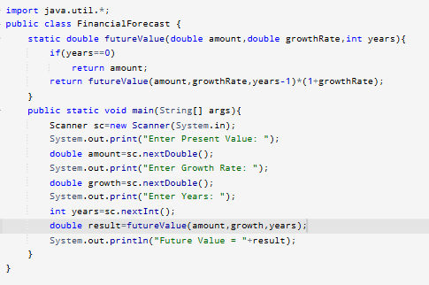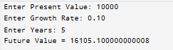
Time Complexity = O(n)

